+

Youth Group At-Home
Summer 2020
Week 4
Activity: diy sponge water bomb war!

Wait a second…… I know what you’re thinking: “What happened to the S’mores?? Well, unfortunately that activity requires 1 big and important thing: boxes. And Daniel ordered the boxes!! They were supposed to be delivered on Wednesday….. but they still haven’t showed up. I know… bummer. It’s ok though! Cause we are gonna have an awesome and fun water bomb war instead, and the s’more activity will still happen. Yes, it will!! Just as soon as the boxes for the ovens show up (hopefully for next week), we’ll do it. But for now, have fun with our SPONGE WATER BOMB WAR!!!

Supplies Needed:
- bucket
- scissors
- small elastic rubber bands (included)
- sponges (included)

- Cut sponges in to 4 quadrants. Each sponge will give you 4 pieces.
- Put 4 pieces together, and tightly wrap an elastic around the middle, holding it all together. (pictured below)

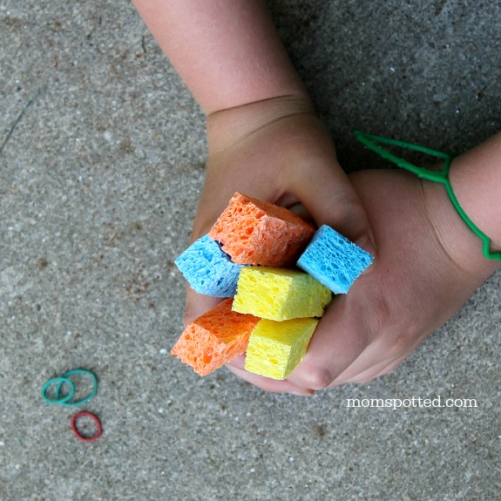

- Soak the sponge in water, then throw it at someone! (but first make sure they say it’s ok.) Your water bombs should look like this
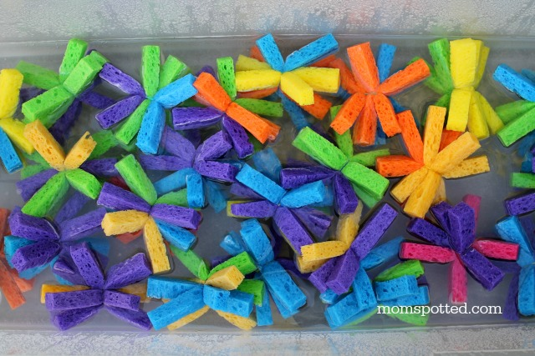

If you want to have an all-out war, here is a suggestion of rules:

WATER WAR RULES
- No throwing Sponge Bombs at faces
- Only 2 Sponge Bombs in your hands at one time
- Can’t throw Sponge Bombs unless you are 10 feet from the bucket
- Allowed at bucket no longer than 1 minute
- No Getting Parents or grandparents

For snack this week we have cheesestrings and granola bars!

Bible story:
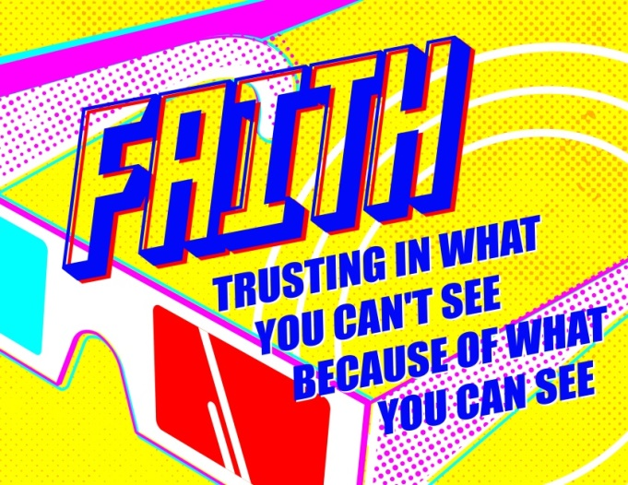
This month’s theme is called:

(Optional pre-video story for kids, or, preferably, kids and parents to read together):
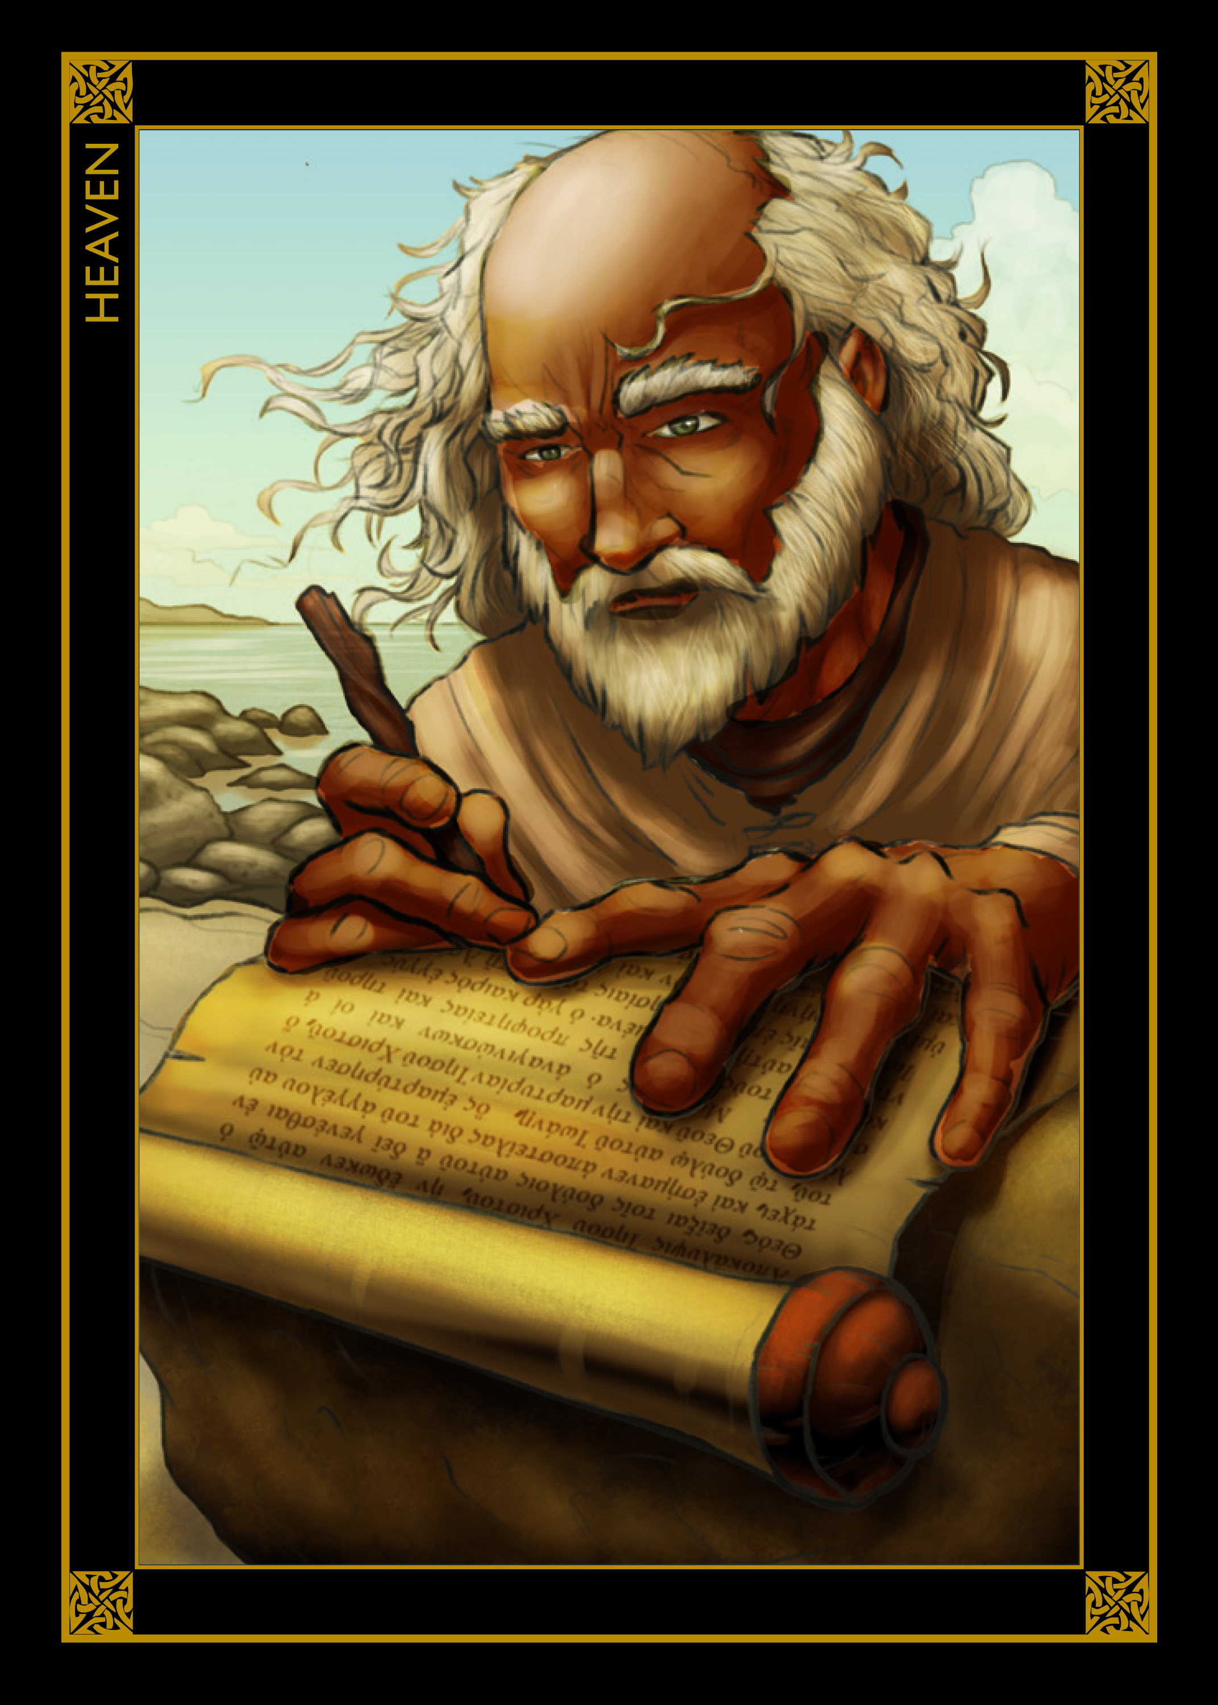
Have you ever wondered what Heaven is like? What do you imagine when you think about it? Do you see clouds? Harps? Angels? How about……a great kingdom that lasts forever? How about a beautiful land where the people are always filled with love, and there is no suffering, sadness, evil, and there is happiness everlasting? How about getting to see the mighty throne of the creator of the universe? This is what God has promised to those who follow Jesus! This week we will be learning about a man named John, a man who was given a glimpse of many amazing things! He saw Jesus, he saw angels, he saw things of heaven, and of the end of the world. John wrote everything down in the last book of the Bible, called ‘Revelation’. We are going to focus on what John wrote in Revelation chapter 21 verses 3-5:
And I heard a loud voice from the throne saying, “Look! God’s dwelling place is now among the people, and he will dwell with them. They will be his people, and God himself will be with them and be their God. ‘He will wipe every tear from their eyes. There will be no more death’ or mourning or crying or pain, for the old order of things has passed away.”
He who was seated on the throne said, “I am making everything new!” Then he said, “Write this down, for these words are trustworthy and true.”
Find out more about John’s story by watching the video below:
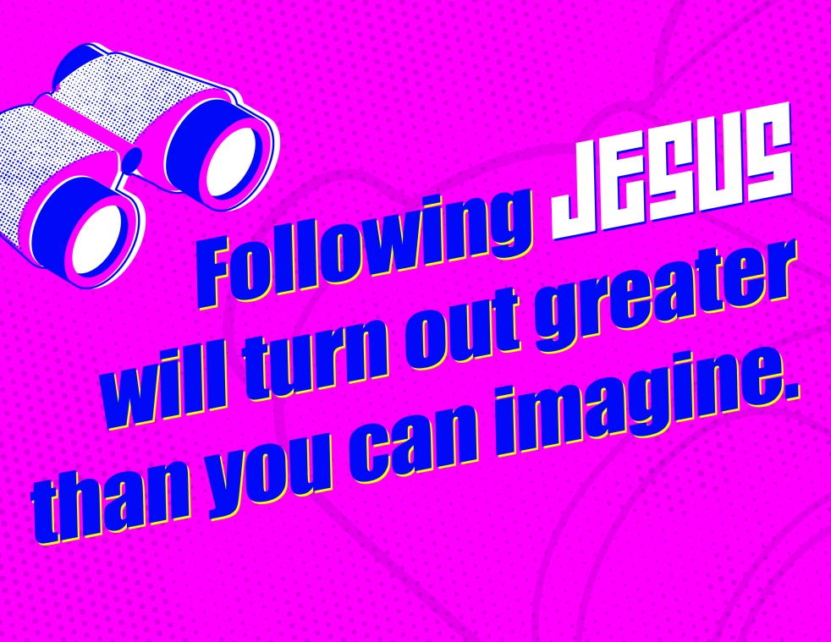

Video links:
Elementary (Grades K-3): https://at-home.playlister.app/19e2da58-13ab-456a-abf7-3c16588be4e7/f723e46c-d6d9-49ac-82d7-47dd3415a666
Preteen (Grade 4+):https://at-home.playlister.app/19e2da58-13ab-456a-abf7-3c16588be4e7/4978a97e-85ae-4acb-b0ae-27612d0f204a

Additional Videos for Teens (not related to story theme):
Middle School (Grade 7+): https://at-home.playlister.app/19e2da58-13ab-456a-abf7-3c16588be4e7/c58cddd3-4e57-4ab5-a570-d6e442dbdb4c
High School (Grade 10+): https://at-home.playlister.app/19e2da58-13ab-456a-abf7-3c16588be4e7/0e0b8965-cd5e-460d-bb6e-3f794acbd03c
ATTENTION FAMILIES!
The Salvation Army in Kamloops is putting on a Family Fun Night in the Park event on Tuesday, August 18th at 5:00 pm at MacDonald Park. The event will be a hot dog, chips, and pop picnic night, complete with games, prizes, and a short message from Daniel.
As per provincial regulations, social distancing measures will be in place, and the event will be capped at 50 participants. Space is limited! Please sign up either by texting Daniel @ 250-819-0843, or by sending a message to The Salvation Army- Kamloops on Facebook. Please include the total number of participants in your Party.
NO DROP INS!
Unfortunately, due to the need for a participant limit, nobody who has not signed up will be allowed entry to the picnic area.

You will need to bring your own blanket to sit on, and we will direct you to an adequately socially distanced spot. Feel free to bring your own chairs, or whatever else you’d like to sit on.

For questions or concerns please contact Daniel @ 250-554-1611 ext. 201 or @ 250-819-0843, or by send a message to The Salvation Army- Kamloops.

Thank you!! We are looking forward to a fun family event!

